Sweep nets bias in

What is the richness of species of flies in the areas?

How well do bottle traps compare to sweep nets in collecting flies in eateries?

Compare the community structure of the kitchen to Palours

Compare the community structure of Taverns to Restaurants

Does the community composition of flies collect change with distance?

**RESULT**

Comparing distance with community composition, there was no significant effect (Mantel statistic r: 0.047, p=0.089), meaning that across distance, the community composition did not change significantly with increasing distance. Longitudinally, there was a non-significant negative relationship between the community similarity and longitudinal distance. Communities become more dissimilar with increasing longitudinal distance, but this was not significant according to Mantel’s test (Mantel statistic r= -0.071, p= 0.977).

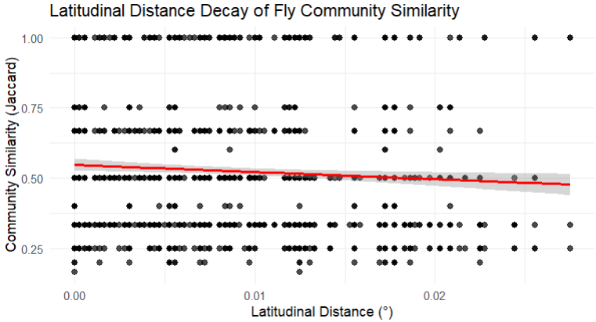

Figure 2: Latitudinal distance decay of fly community (Jaccard) similarity. The red line shows the trend line with 95% confidence intervals.

